Computer Programming Using Kivy 1.7.2 - Canvas 3 - Main Event Loop
GOAL: make a program that keeps moving while you interact

Open the sample program and add the refresh method which will move the characters:
- Open Ninja-IDE
- File, Open, R:\ComputerProgramming\Examples\canvas3NeedsRefresh.py
- File, Save As, Computer, H:, then name it canvas3.py
- Add a refresh method in the Character class that moves the character toward its destination using the code below. The python min function can be used to get whatever is smaller: in this case either the one-dimensional distance to the target or the speed (in pixels per frame), so the character doesn’t go past its target:
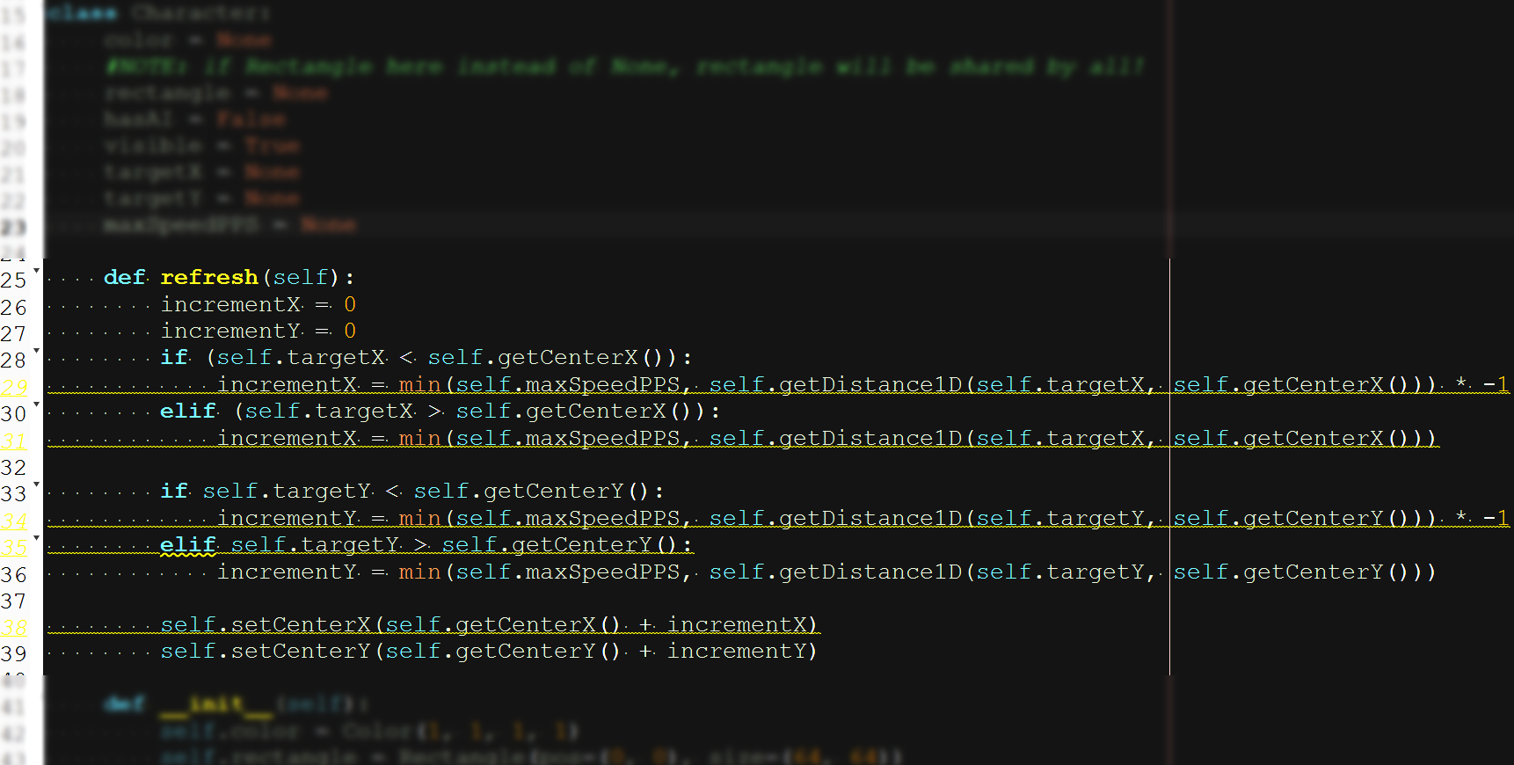

- Call the refresh method for each character every time the screen updates (60 frames per second):
  - Delete the word “pass” which just means skip because there is nothing to do, then add the refresh lines:
